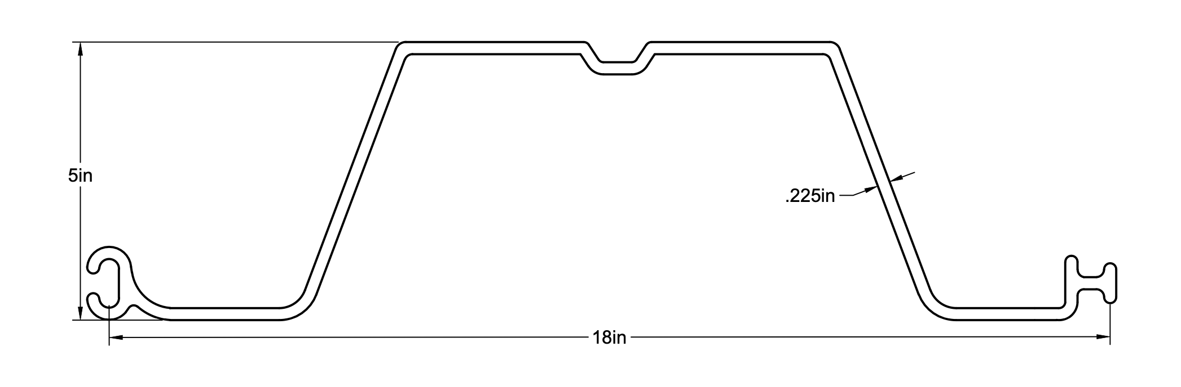
Attribute | Imperial |  | Metric
 | Value | Unit | Value | Unit
Allowable Moment (M_allow) | 4968.75 | ft-lb/ft | 6.74 | kN·m/m
Section Modulus (Z) | 7.95 | in³/ft | 130.28 | cm³/m
Moment of Inertia (I) | 20.00 | in⁴/ft | 832.48 | cm⁴/m
Span (L) | 8.00 | ft | 2.44 | m
Uniform Load (w) | 250.00 | plf | 3648.48 | N/m
Max Moment (M_max) | 24000.00 | lb-in/ft | 2712.00 | N·m/m
Bending Stress (σ) | 3018.87 | psi | 20.81 | MPa
Stress Utilization | 0.20 |  | 0.20
Deflection (δ, E) | 2.09 | in | 53.20 | mm
L/δ | 45.83 |  | 45.83
Thickness (t) | 0.23 | in | 5.72 | mm
Section Depth | 5.00 | in | 127.00 | mm
Section Width | 18.00 | in | 457.20 | mm
Ultimate Tensile Stress | 9000.00 | psi | 62.05 | MPa
Material | Engineered Fiber-reinfocecd Rigid PVC
Profile | Box
UV Stabilized | Yes
Co-Extruded | Yes

